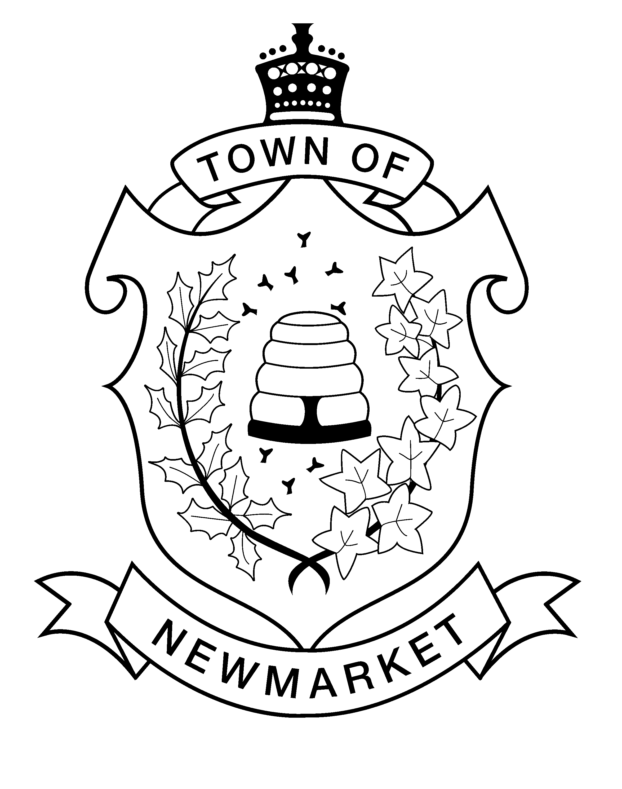
Town of Newmarket
Community Services
Recreation and Culture Department
905-953-5300, ext. 2600
recreation@newmarket.ca

Form A: Exemption Form
Events at Town Facilities Involving Animals

About your event:
Description | YOUR ANSWERS
Event Date(s)

Facility Requesting

Description of event:

Reason for Exemption
QUESTIONS | YOUR ANSWERS
Who does your event service?

What does your company do?
(For example, start with “We provide”)

Reason for exemption
(please note that you may attach any information about your event or company to aid with the decision)

Town of Newmarket – Office Use Only
Accepted
Denied

